2303a51083
V Rishi Shankar Sai Kapil
Batch-17

Question 1: Zero-Shot Prompting (Palindrome Number Program)
Prompt:
#write a function that checks input number(int or float) is palindrome or not , take input from user
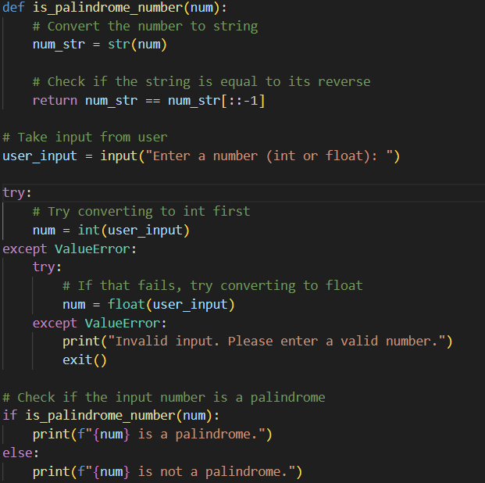
Output:
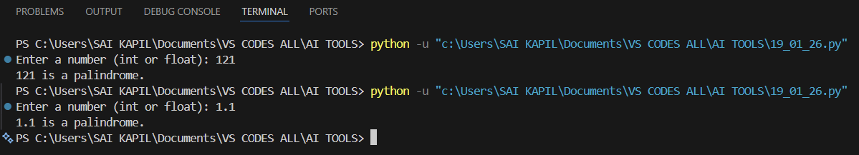
Analysis:
Zero-shot prompting generated a simple and correct palindrome function, but it does not handle negative numbers or input validation.
Question 2: One-Shot Prompting (Factorial Calculation)
Prompt: #write a function for calculating factorial of a given number
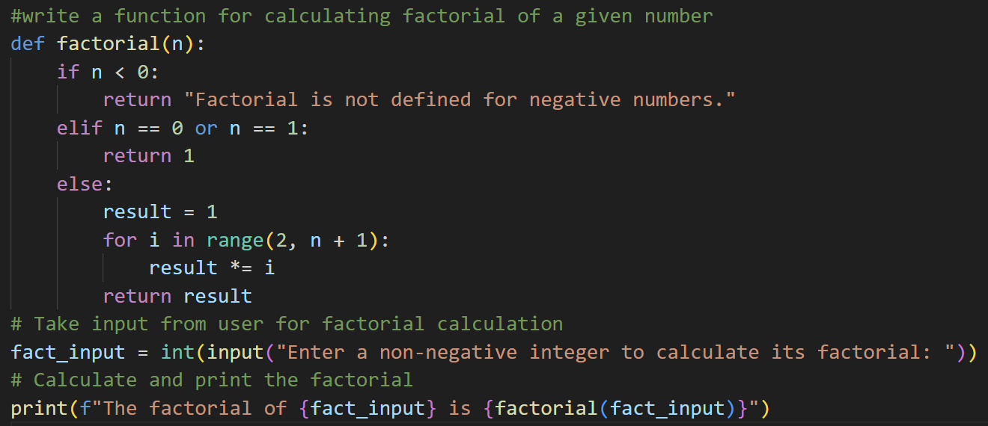
Output:
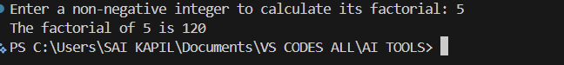
Analysis:
Zero-shot prompting generated a simple and correct palindrome function, but it does not handle negative numbers or input validation.
Question 3: Few-Shot Prompting (Armstrong Number Check)
Prompt:#write a function to check whether a given number is armstrong or not, 153,370->output Armstrong 173 -> not armstrong
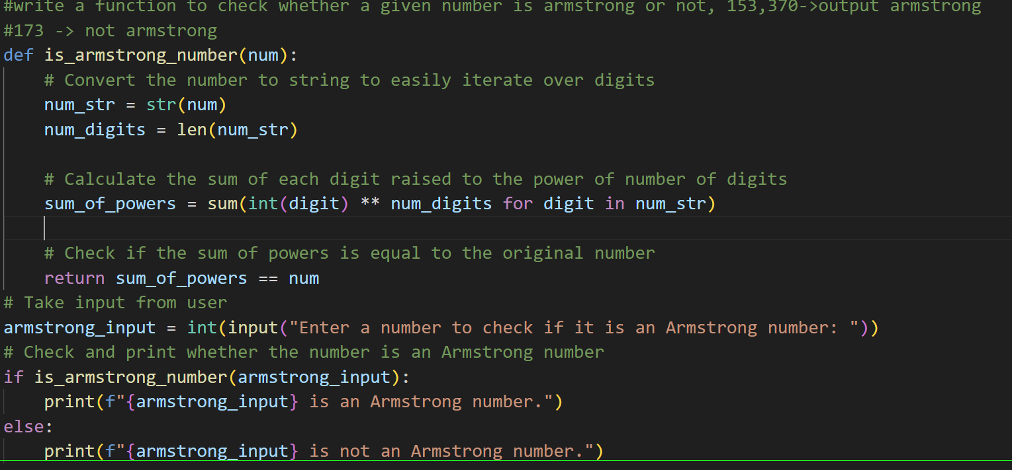
Output:
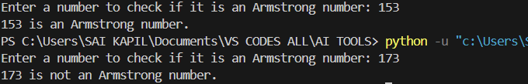
Analysis:
Zero-shot prompting generated a simple and correct palindrome function, but it does not handle negative numbers or input validation.

Question 4: Context-Managed Prompting (Optimized Number Classification)
Prompt:
write a function that checks whether number is prime , composite, or neither and unsure proper input validation(whether input is float or string or special character or negative number)Optimize the logic for efficiency.
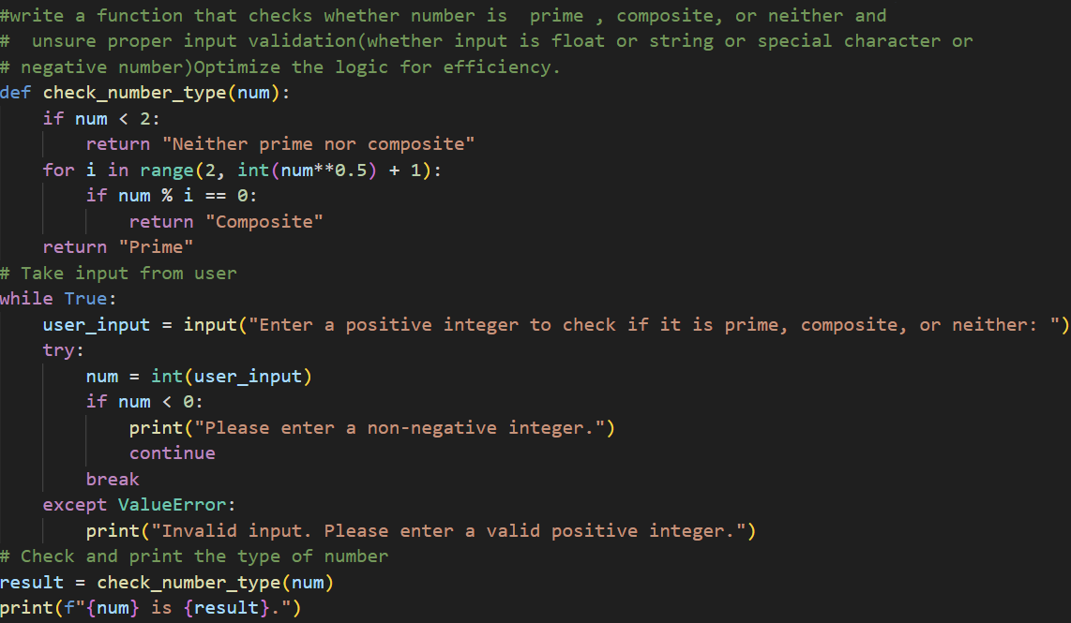
Output:
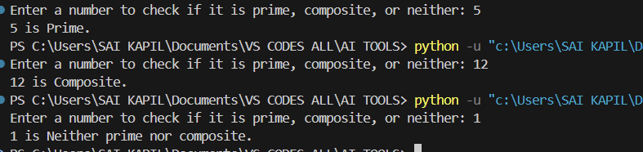
Analysis:
Zero-shot prompting generated a simple and correct palindrome function, but it does not handle negative numbers or input validation.

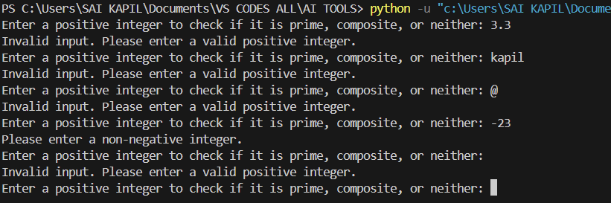

Question 5: Zero-Shot Prompting (Perfect Number Check)
Prompt:
#write a functtion to check whether a given number is perfect or not , again take input from user never terminate the program until valid input is given
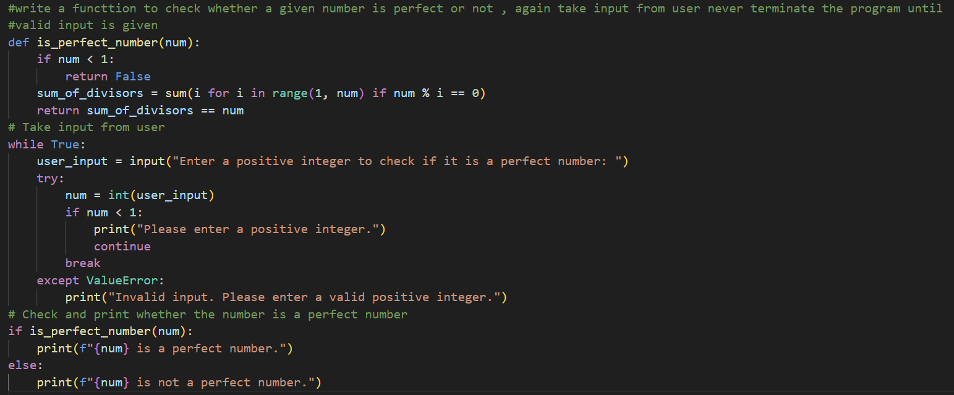
Output:
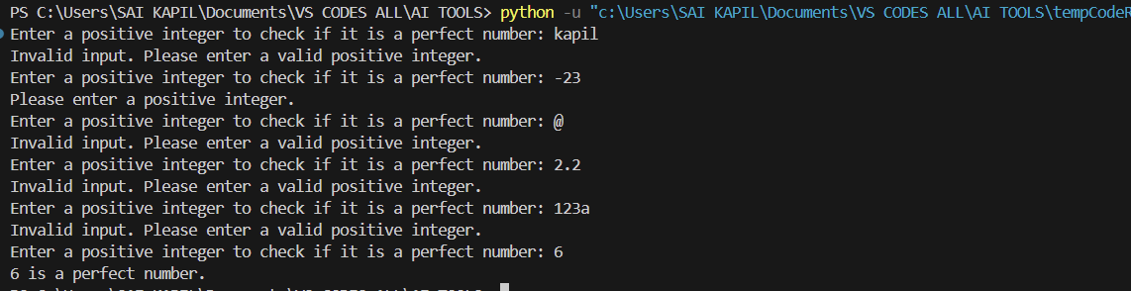
Analysis:
Zero-shot prompting generated a simple and correct palindrome function, but it does not handle negative numbers or input validation.
Question 6: Few-Shot Prompting (Even or Odd Classification with
Validation)
Prompt:
#write a functtion to check whether a given number is even or odd , again take input from user never terminate the program until valid input is given , 8-> even , 15-> odd 0-> even

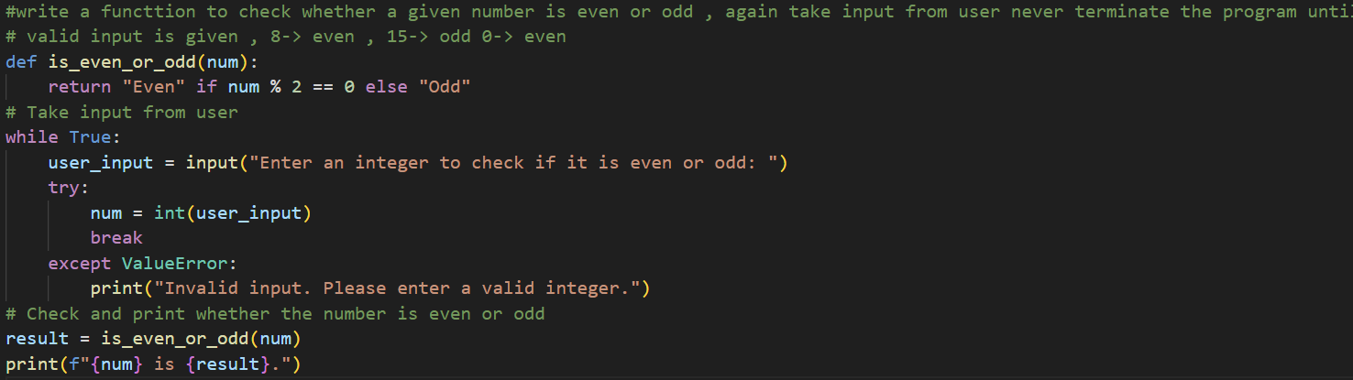
Output:
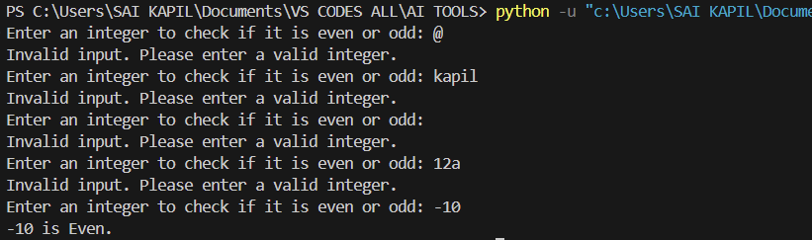
Analysis:
Zero-shot prompting generated a simple and correct palindrome function, but it does not handle negative numbers or input validation.

